EXPERIMENT 11
PROCEDURES
Aim:
- Create a table with attributes students and marks.
- Insert values into the table.
- Create a procedure to get the merit students (marks > 50).
- Create a procedure to get marks of a given id (using in).
- Create a procedure to display highest marks (using out).
- Create a procedure to get marks of a given id (using in and out).
QUERIES:

Create a table with attributes students and marks.
Insert values into the table.
Create a procedure to get the merit students (marks > 50).
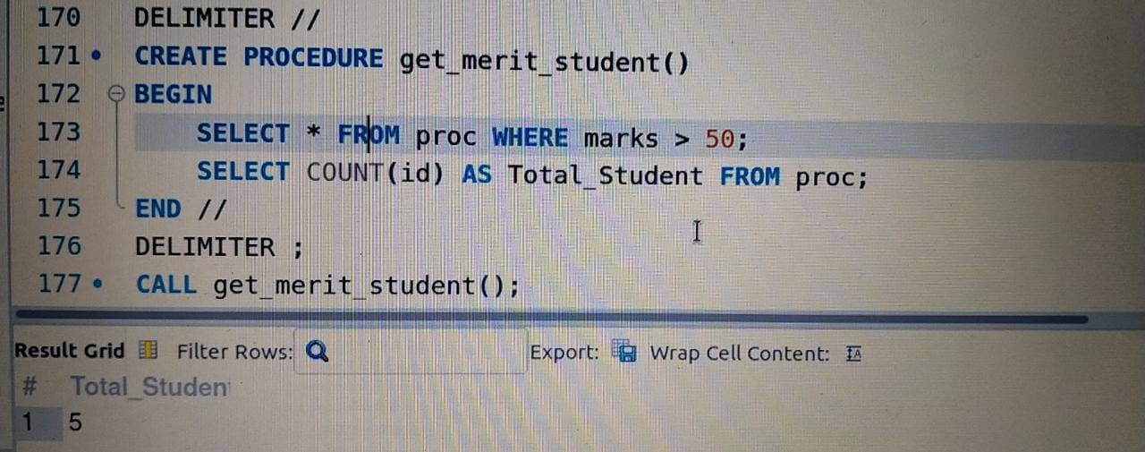

Create a procedure to get marks of a given id (using in).
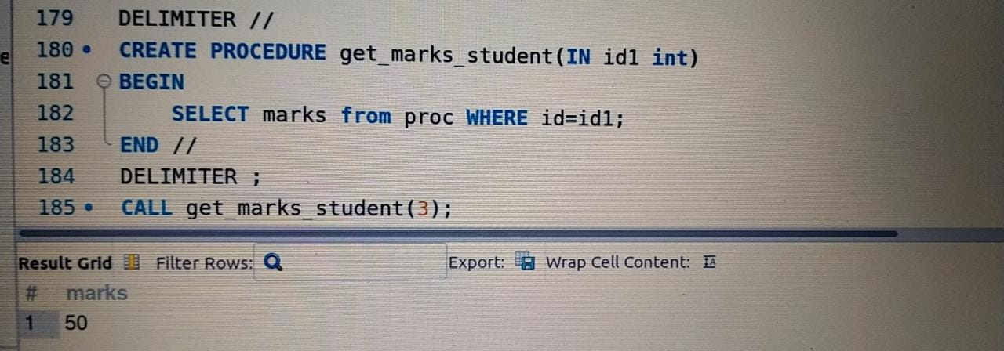
Create a procedure to display highest marks (using out).
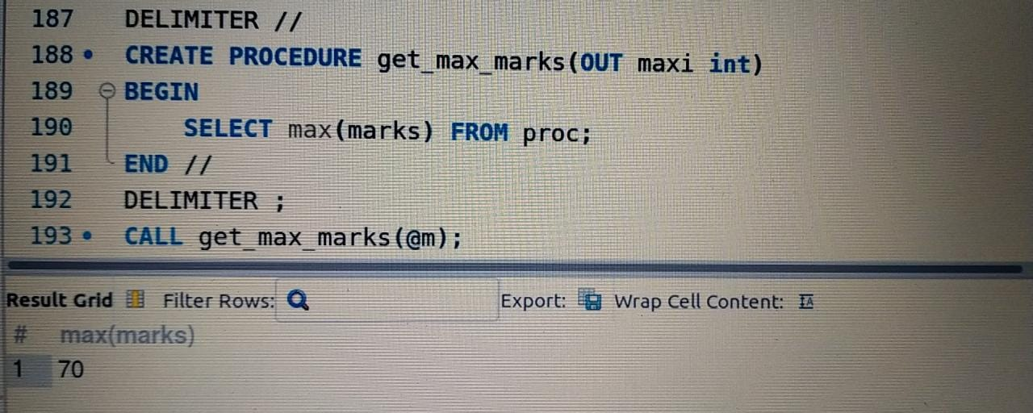
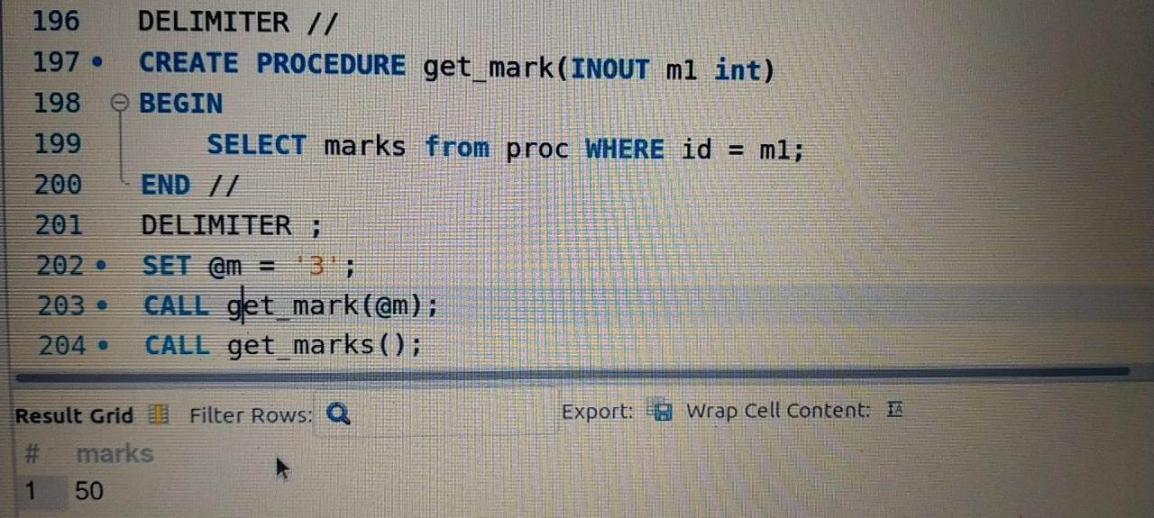
Create a procedure to get marks of a given id (using in and out).

